**SYMBIOSIS INSTITUTE OF TECHNOLOGY, PUNE**



**INFORMATION TECHNOLOGY**

**2016-20**

**LAB REPORT**

**TOPIC- Frenzy,The Fantastic Foodcourt**

**SUBMITTED BY:-**

**Ankisha Malhotra**

**PRN.No- 16070124011**

**Date of Submission- 31/10/2018**

**INDEX**

|  |  |  |
| --- | --- | --- |
| S.No. | Topic |  |
| 1. | Introduction |  |
| 2. | Description of Website |  |
| 3. | Technical Explanation: Front-end and Back-end |  |
| 4. | Screen-shots |  |
| 5. | Conclusion |  |
| 6. | Acknowledgement |  |

**WEBSITE DESCRIPTION**

Our website is a website to manage the activities in a food court. It helps in stroing the customers details .

As soon as we register the details are added in the database and when the same person logins with the registered username and password our website is then ready to take orders from customer.

A simple example of it would be:

First lets register in the website.

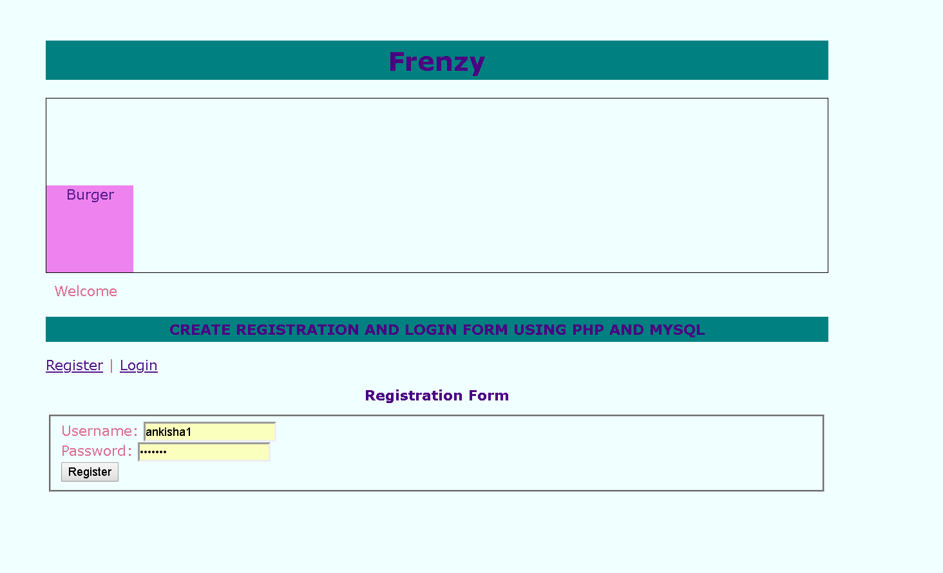

After successful registration it shows “Account Successfully” as shown in the screenshot.

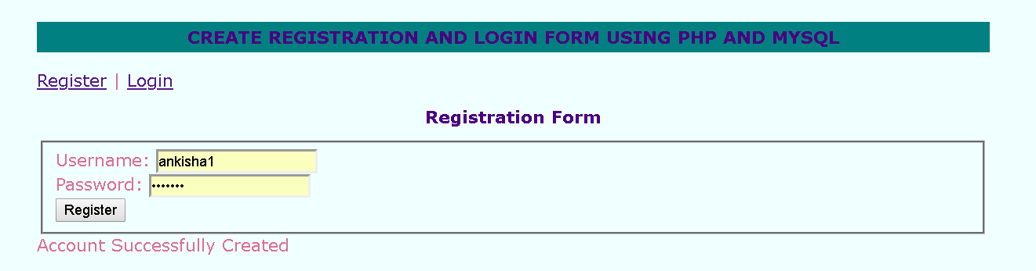

Then we login from the same registerd username and password.

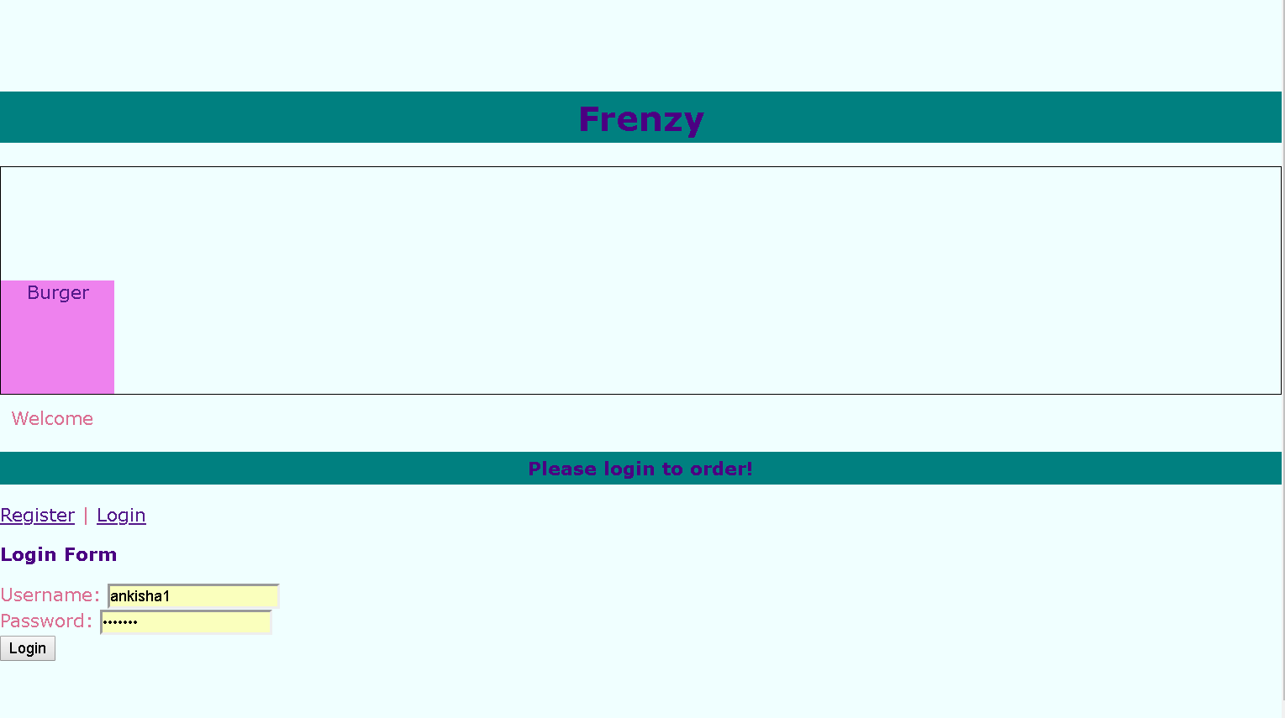

The login user_id ,name of the user and password is saved in the database uder the table “**LOGIN**”

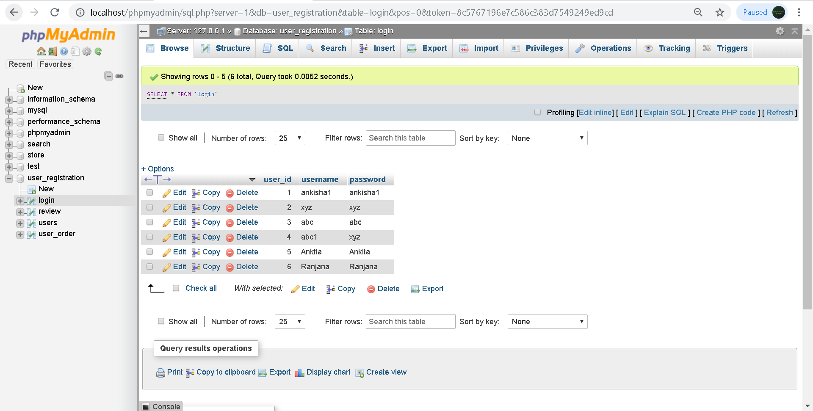

Then after clicking on the submit button we get the following main page.

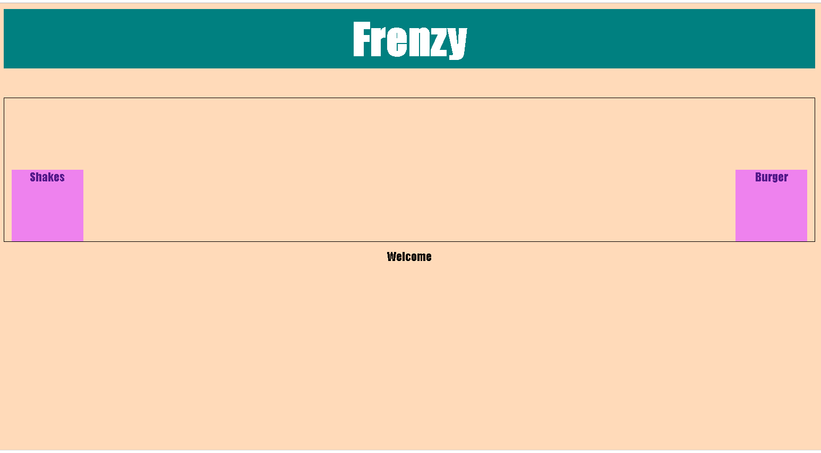

And now you can click on any displayed links burgers and shakes to order.

Suppose the customer wants to order any shakes he will click on the link shakes and will get this

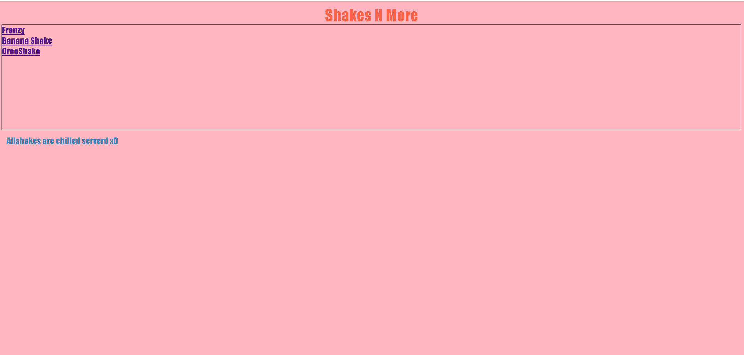

If he wants to order Banana Shake he will get the recepie of the Banana shake displayed

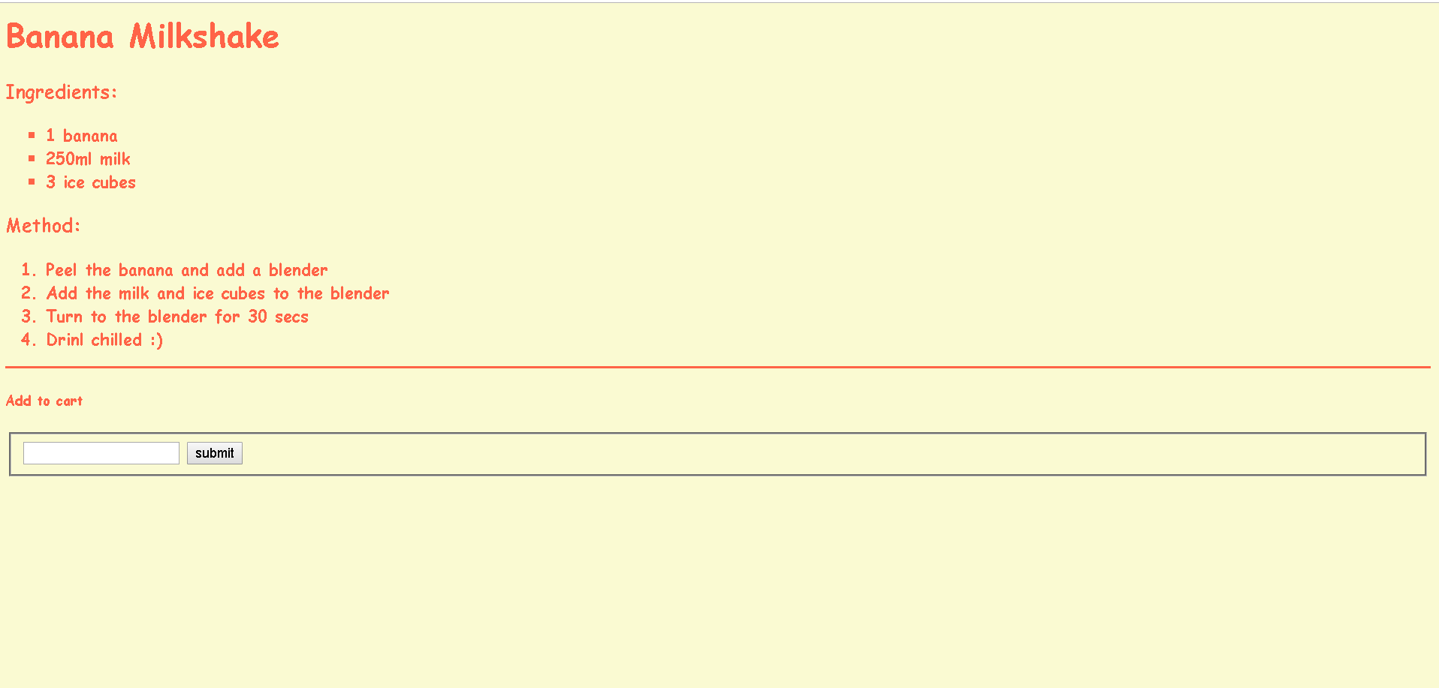

He can add to cart the dish item and also Mention his preferences in the comment box and press submit button , By clicking on the submit button the Comment is stored in the database corresponding to the user_id (i.e)which customer has login his comment is stored in the database usder the table “**REVIEW**”.

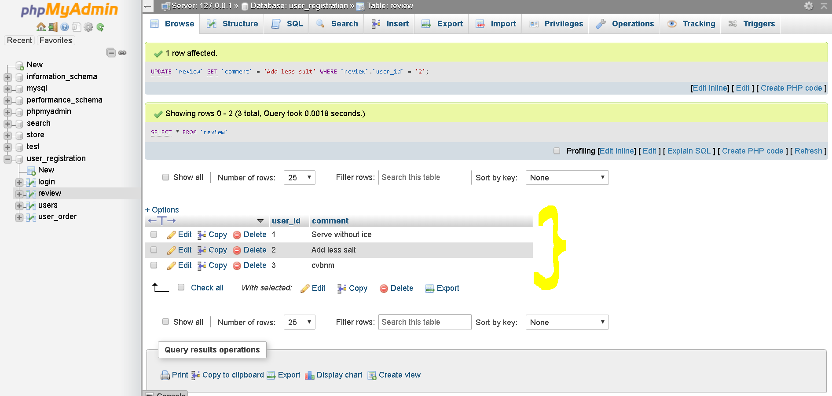

Other Frenzy foodcourt has other dishes

Bob’s Special Burger

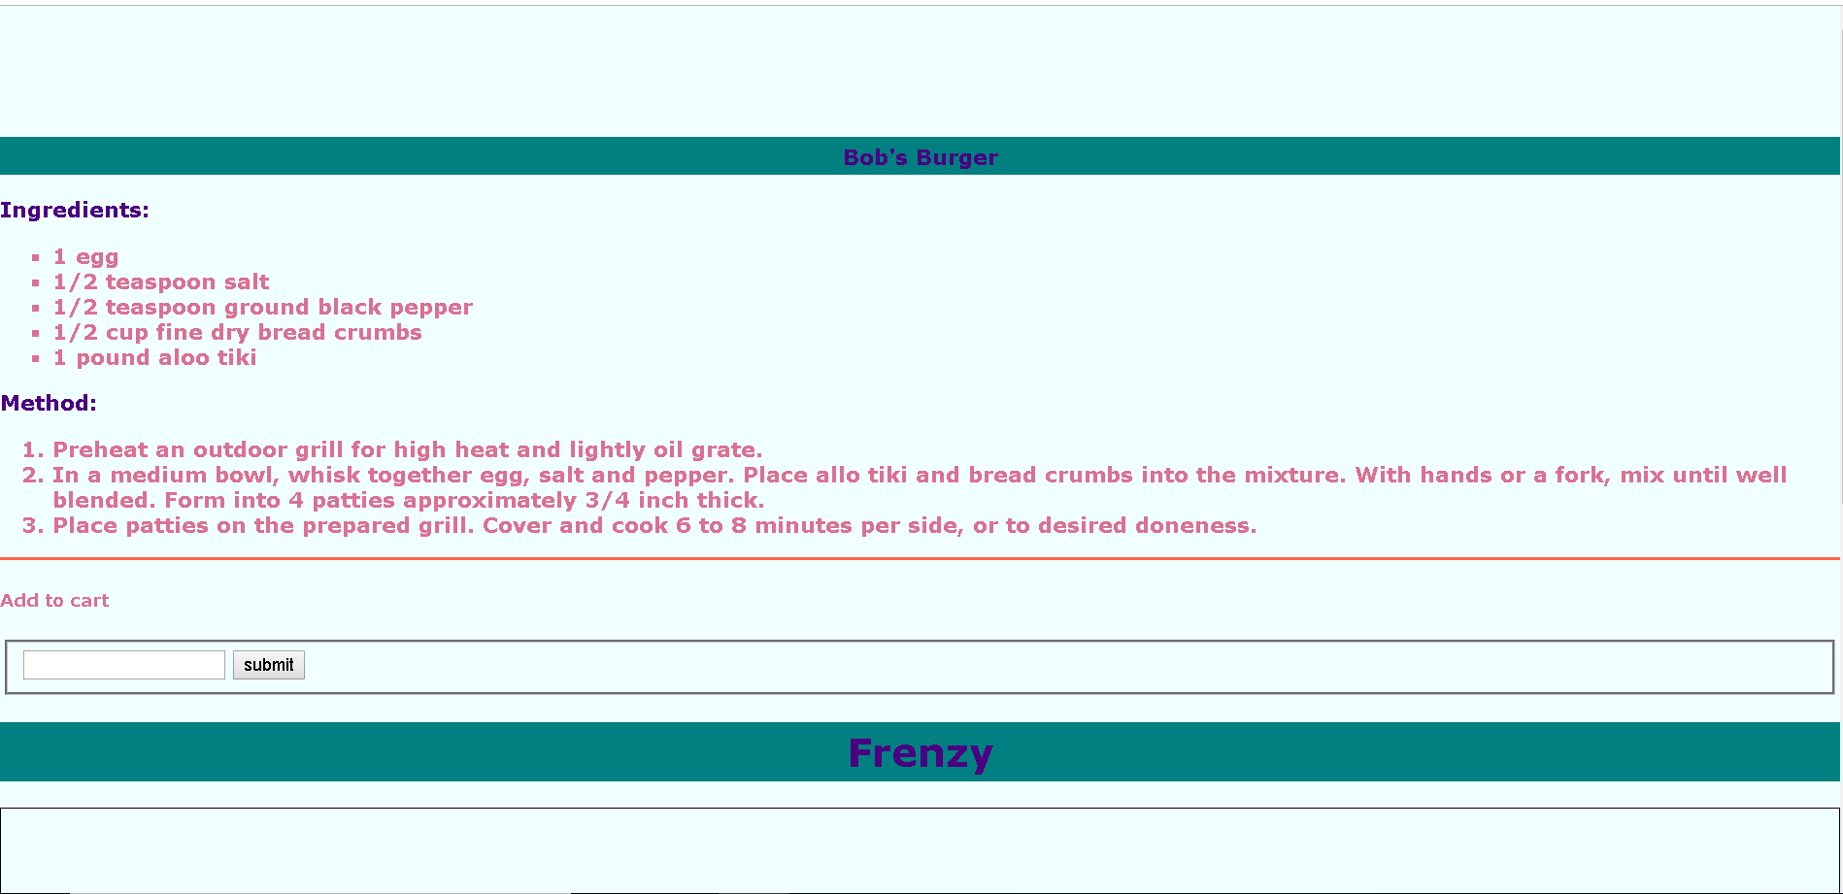

Oreo shake

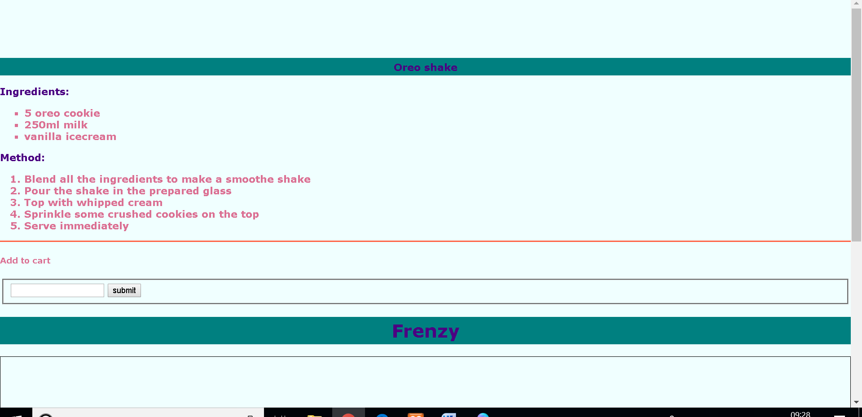

**TECHNICAL DETAILS**

**FRONT-END:-**

The front has been made using structuring by HTML and styling by CSS.

HTML stands for Hyper Text Markup Language, which is the most widely used language on Web to develop web pages..

**BACK-END:**

The back-end has been made with php and mysql.

The PHP Hypertext Preprocessor (PHP) is a programming language that allows web developers to create dynamic content that interacts with databases. PHP is basically used for developing web based software applications. This tutorial helps you to build your base with PHP.

**Conclusion**

Making this website helped learning website development in detail and the various aspects of front and back-end development.

If implemented on a large scale it can help in posting a website online that helps the shopkeepers of local foodcourt to keep a track on the sellingand getting maximum output by looking at the past sales.

**ACKNOWLEDGEMENT**

 I would like to express my special thanks of gratitude to my teacher Ms Samadrita Guha who gave me the golden opportunity to do this wonderful project on the topic of website development, which also helped me in doing a lot of Research and i came to know about so many new things. I am really thankful to her for helping me learn such amazing things in such a short span of time.

Also I am very thankful to the college authorities for providing us with the much needed support and resources.